TRAFFIC ANALYSIS AND CONGESTION REPORT
Document Title: Traffic Analysis and Congestion Report
Project: Cluster 6 – Darvycom Australia
Unit: ICTTEN615 – Manage Network Traffic
Prepared by: Leonardo Matias Ciarcia
Date: 02/02/2026
Version: 1.0

1. Purpose
The purpose of this report is to analyse network traffic within the Darvycom Australia network solution and identify actual or potential congestion problems. The report also considers network performance measurements and provides recommendations to maintain reliable network services.
PRTG Network Monitor is used as the main network monitoring solution for the project. Supporting tools such as Ping, Traceroute, SNMP and NetFlow may also be used to collect and verify network information.
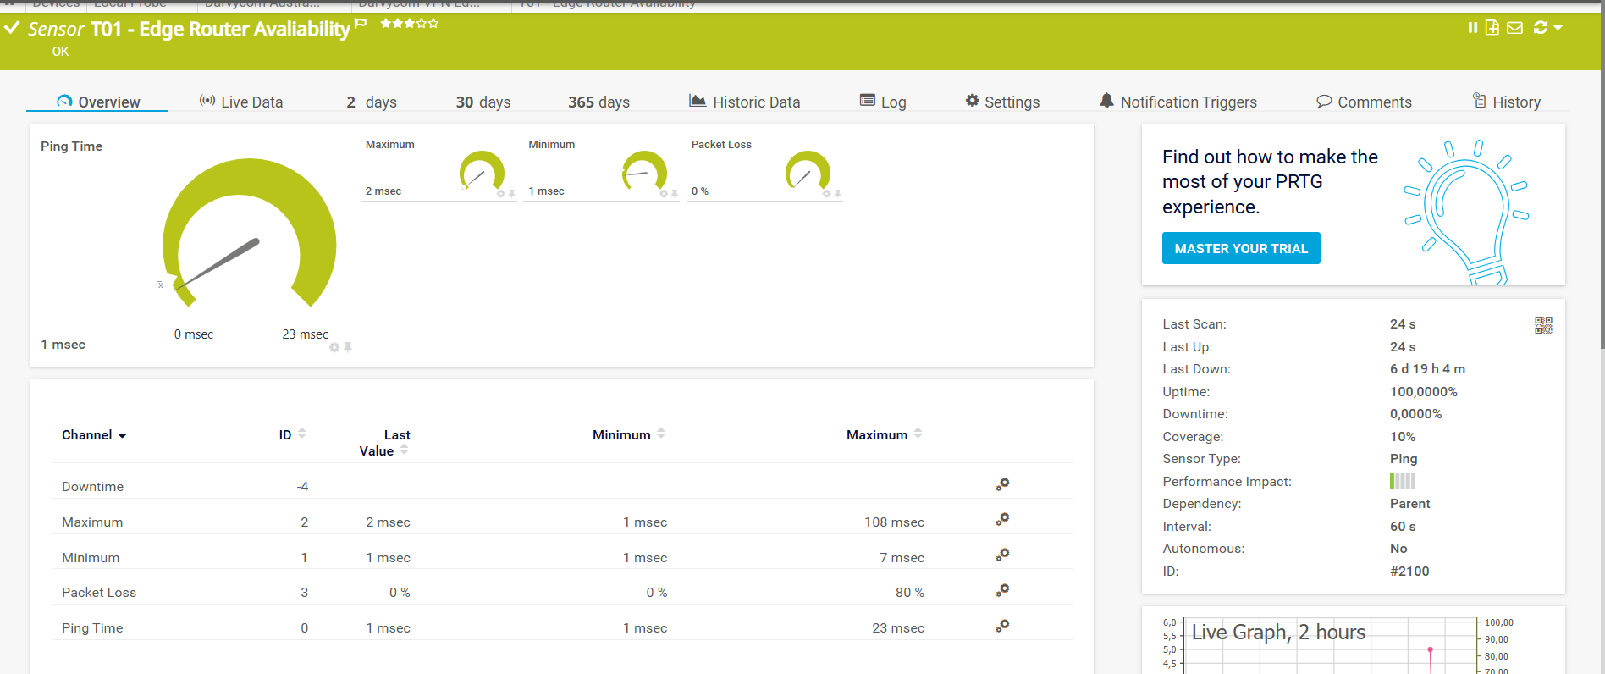

“PRTG Network Monitor dashboard showing active monitoring of the simulated Darvycom Australia network environment.”

2. Scope
The traffic analysis focuses on the main components and communication paths within the Darvycom Australia network, including:
- Network routers
- Core and access switches
- Data and voice services
- Servers
- Wireless network services
- Internet connectivity
- VPN services
- Video conferencing
- VoIP/IP telephony
- User devices
The analysis considers current traffic conditions, historical traffic information and potential future network requirements.

3. Monitoring and analysis method
PRTG Network Monitor is used to collect network performance information through appropriate sensors.
The main measurements considered are:
- Bandwidth utilisation
- Throughput
- Latency
- Packet loss
- Jitter
- Device availability
- CPU utilisation
- Memory utilisation
- Interface errors
- Interface discards
- Traffic volume
- Top talkers and applications where NetFlow is available
Current results should be compared with historical data to determine whether performance problems are temporary, recurring or increasing over time.

4. Traffic measurement results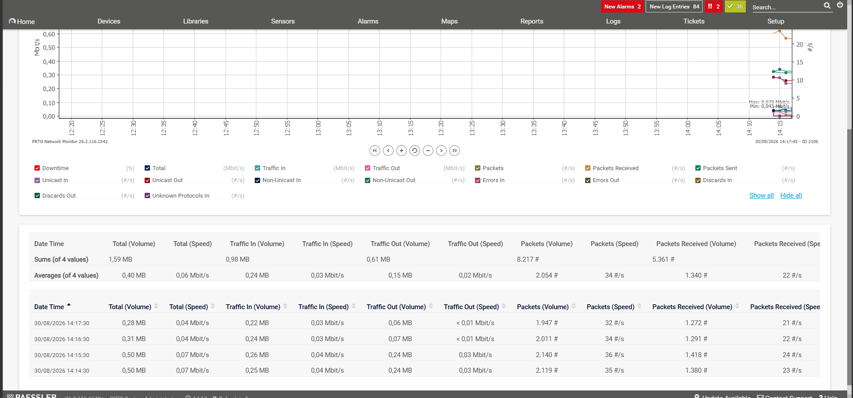

Bandwidth utilisation

Measurement | Status | Interpretation
Bandwidth utilisation | Normal | Shows how much network capacity is currently being used
Latency | Normal | Indicates delay between network devices
Packet loss | Normal | Indicates packets being lost during transmission
Throughput | Acceptable | Shows actual successful data transmission
CPU utilisation | Normal | Indicates processing demand on the network device
Availability | Available | Shows reliability of the monitored service

5. Potential network traffic problems

5.1 High bandwidth utilisation
High traffic generated by voice, video conferencing, cloud services, server access, downloads and other applications may cause network links to approach their maximum capacity.
Potential impact:
- Increased latency
- Reduced throughput
- Packet loss
- Slow application response
- Poor voice and video quality

5.2 Packet loss and latency
Congestion or network faults can cause packets to be delayed or dropped. This has a significant effect on real-time services such as VoIP and video conferencing.
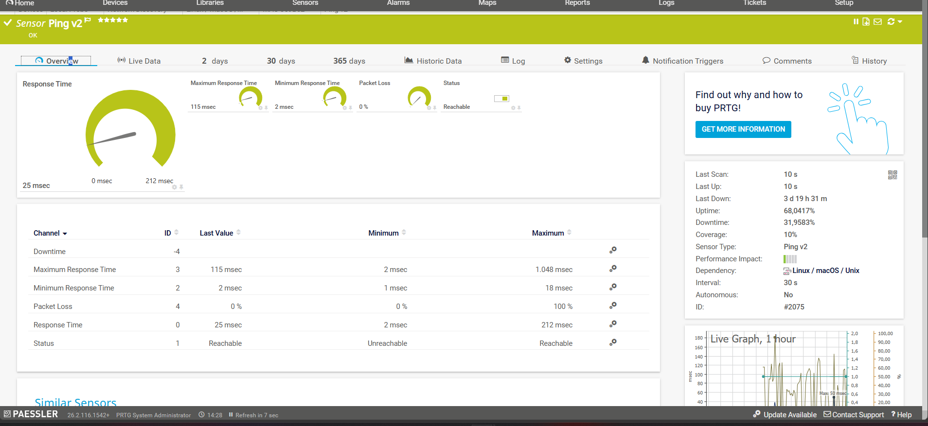
response time: 115ms Packet loss: 0 %

5.3 Device processor overload
High CPU or memory utilisation on routers, switches, servers or security devices may limit the rate at which traffic can be processed.

5.4 Interface errors and discarded packets
Network interfaces may experience errors due to cabling problems, configuration issues, excessive traffic or device faults.

5.5 Unnecessary or non-business traffic
Streaming, large downloads, unnecessary applications and uncontrolled background services can use bandwidth required for important business applications.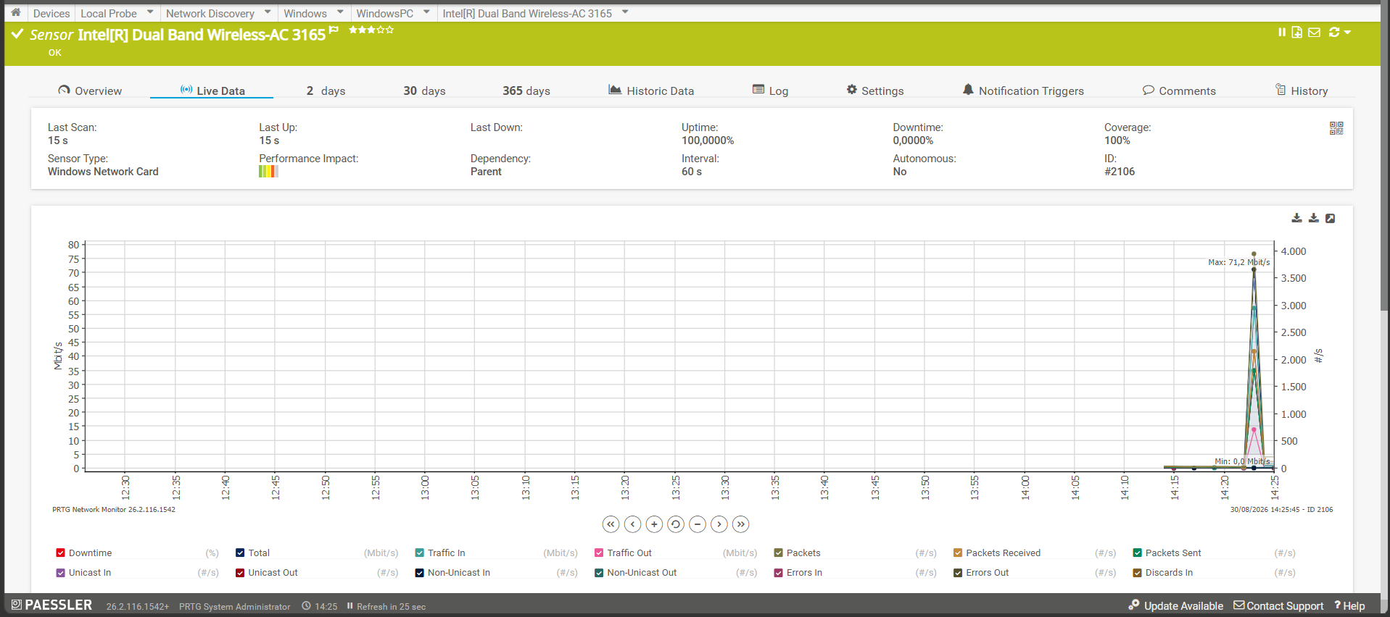
“The increase in bandwidth utilisation demonstrates how additional network demand can create higher loading on a network link. If sustained, this type of traffic growth could contribute to congestion.”

6. Congestion assessment
Network congestion is considered to exist when traffic demand exceeds the available network capacity or when network devices cannot process traffic at the required rate.
Possible congestion indicators include:
- Sustained high bandwidth utilisation
- Increased packet loss
- Increased latency
- High jitter
- Reduced throughput
- Increased interface discards
- High CPU utilisation
- PRTG Warning or Down alerts
PRTG historical graphs can help determine whether congestion occurs only during specific periods or represents a longer-term capacity problem.

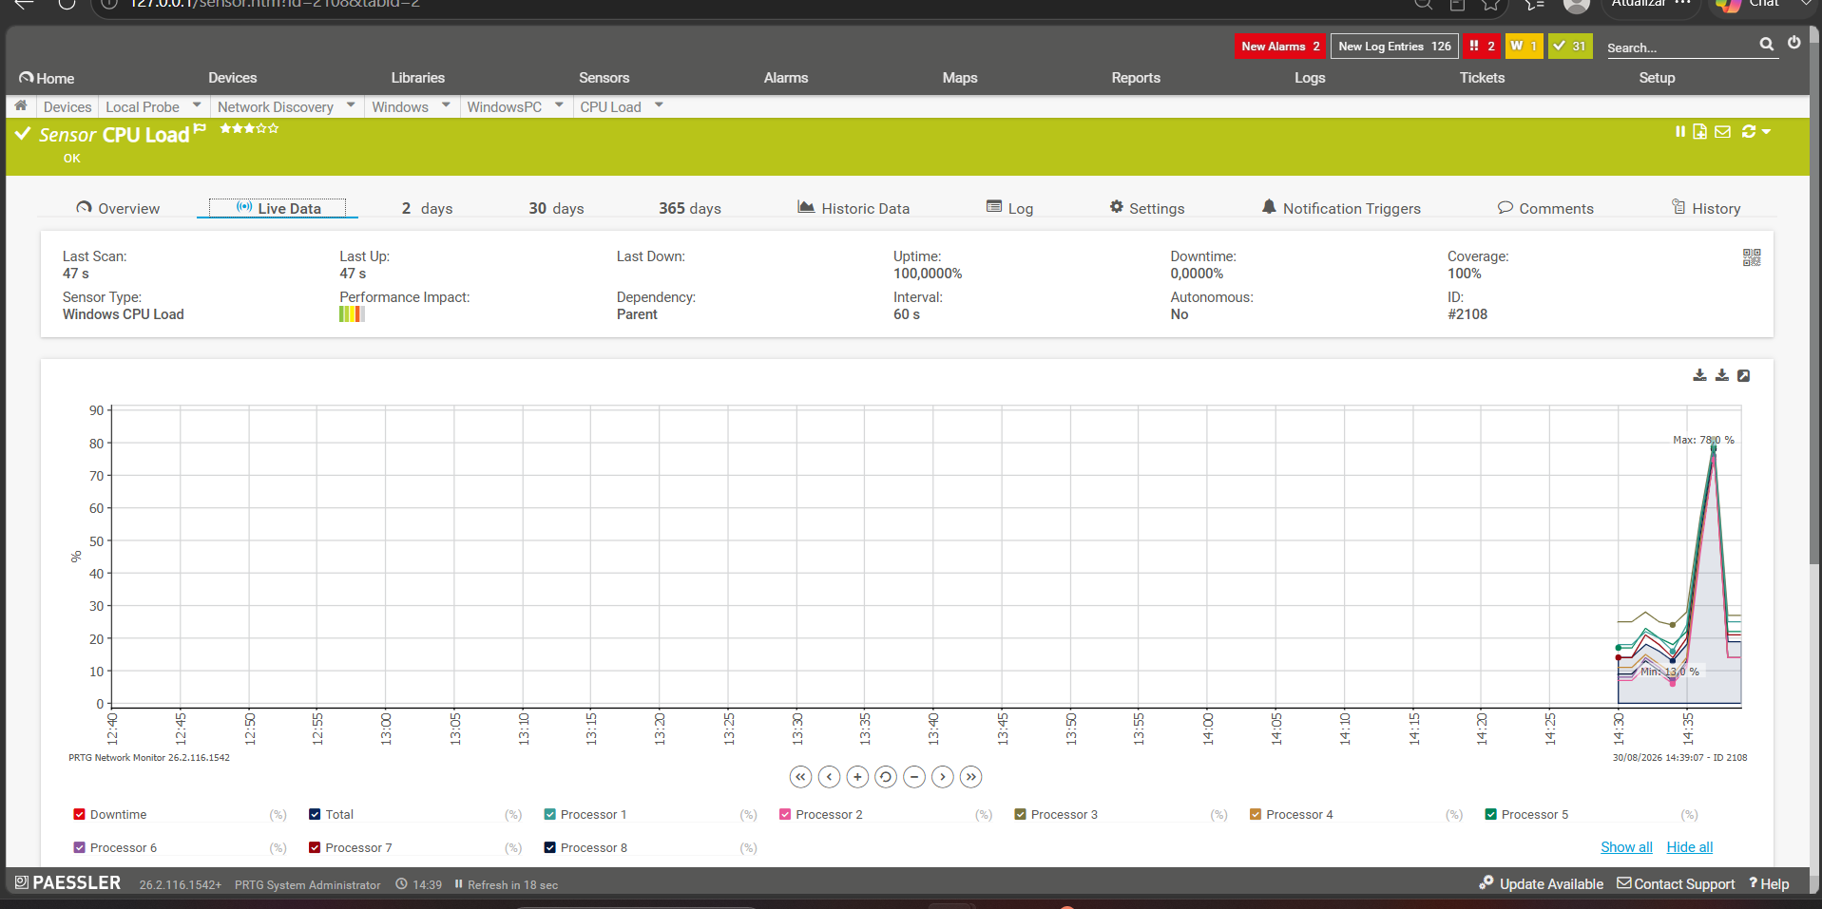
“The CPU sensor was used to determine whether additional network and system activity significantly affected processing resources.”

“Controlled PRTG threshold test demonstrating an alert when the monitored value exceeded the configured limit.”

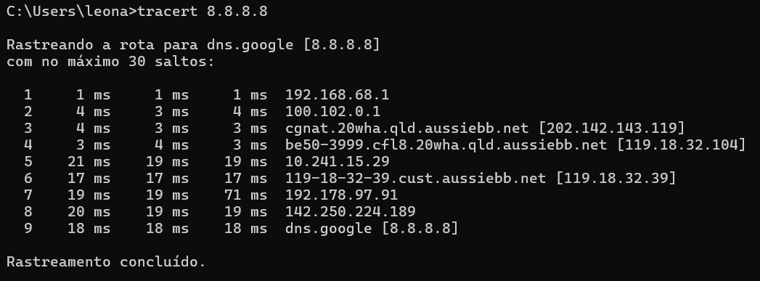
“The traceroute test identified the path used to reach the destination and assisted with identifying possible delays or unavailable hops.”

7. Recommendations
The following recommendations are proposed for Darvycom Australia:
- Continue monitoring critical devices and interfaces with PRTG.
- Establish normal and peak-traffic baselines.
- Configure warning and critical performance thresholds.
- Apply QoS to voice, video and critical business applications.
- Schedule backups and large software updates outside busy periods.
- Apply traffic shaping or rate limiting where appropriate.
- Restrict unnecessary non-business traffic.
- Investigate repeated interface errors and packet loss.
- Upgrade network links where monitoring confirms insufficient capacity.
- Review historical traffic information regularly for capacity planning.

8. Conclusion
The traffic analysis process provides Darvycom Australia with information about current network performance and potential congestion risks. PRTG provides continuous monitoring and historical information that can be used to identify performance problems before they cause major service disruption.
Applying appropriate traffic controls and regularly reviewing traffic trends will assist Darvycom Australia in maintaining network availability, performance and reliability.

